Federated Rural Electric Trust Application for Organization/Agency to Request Funding
Submission Requirements

The information contained in this statement is for the purpose of obtaining funding from Federated Rural Electric Trust on behalf of the undersigned. The undersigned understands the information provided herein is used to determine funding, and the undersigned represents and warrants that the information provided is true and complete and that Federated Rural Electric Trust may consider this statement as continuing to be true and correct until a written notice of change is provided. Federated Rural Electric Trust is authorized to make all inquiries they deem necessary to verify the accuracy of the statement made herein. Federated will treat the information of this application as confidential.

Contact for more information or with questions:  Federated Rural Electric Trust, PO Box 69, Jackson MN 56143-0069  507-847-3520, 728-8366 or 1-800-321-3520  Email: info@federatedrea.coop |  | 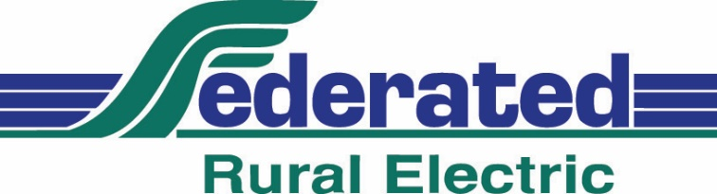
Applicant Information:
Organization: | Work Phone: |  | Cell Phone: |  | Home Phone:
Street Address: |  |  | City: |  | State: | Zip:
Email Address:

Name of organization representative completing this form: |  |  |  |  | Date:
Is the Organization requesting funding exempt from payment of income tax under the 501[c]3 of the Internal Revenue Code? If yes, email or mail a copy of the letter (Form 501[c]3) from the IRS to Federated. |  |  |  |  | Yes  No
A copy of financial statement(s) for the most previous year should be provided. If that’s not available, attach a statement to this email or mail to Federated detailing revenue, sources of revenue, program expenditures, administrative expenses and cash/assets on hand. Are the financials being mailed or emailed? |  |  |  |  | Mailed  Emailed
Has this organization received funds from the Federated Rural Electric Trust before? |  |  |  |  | Yes |  | No
If yes, how many times?
Does this organization receive its electric bill from Federated? |  |  |  |  | Yes |  | No
If yes, does this group participate in Federated’s Operation Round Up Program? |  |  |  |  | Yes |  | No
Application Continued on Next Page…

Organization Service Territory:
Approximate number of individuals, families or groups served in Federated Rural Electric’s service area that consists of the following townships in Jackson and Marin Counties:

Jackson County:
LaCross, Weimer, Delafield, Christiania, Alba, West Heron Lake, Heron Lake, Enterprise, Ewington, Rost, Hunter, Des Moines, Wisconsin, Round Lake, Sioux Valley, Minneota, Middletown and Petersburg Townships.

Martin County:
Westford, Nashville, Fox Lake, Fraser, Rutland, Center Creek, Jay, Manyaska, Rolling Green, Fairmont, Pleasant Prairie, Lake Fremont, Lake Belt, Tenhassen, Silver Lake and East Chain Townships.

Individuals

Families

Groups

Does this agency serve outside of Federated Rural Electric’s service area? | Yes | No
If yes, please provide information on the number serviced and their location:

Application Continued on Next Page…

If you need more space to answer these questions, please create a separate Word Document and attach to email. Remember to include your financial statements in the attachments as well (can be PDF, TIF, JPG, Excel or links).
State the purpose of the organization/agency’s request. Include amount requested and specific use of funds.
List other sources of funding for the request that’s described above.
How are the agency’s programs measured for effectiveness?
Please list two references. May not be a director or employee of Federated Rural Electric or the Federated Rural Electric Trust. One reference should be an organization that has donated funds to your organization recently. Include their phone number and town.
Name: | Phone:
Name: | Phone:
Once application is complete, please save it as a Word document and email it as an attachment to info@federatedrea.coop.

